Characterizing and correcting the underestimation of vessel diameter due to OCT artefacts

Conrad W. Merkle^{a,*}, Yash Patelª, and Bernhard Baumann^{a,b}
ªCenter for Medical Physics and Biomedical Engineering, Medical University of Vienna, Austria
^{b}Institute of Biomedical Physics, Medical University of Innsbruck, Innsbruck, Austria

INTRODUCTION
Optical coherence tomography angiography (OCTA) is an extension of OCT that visualizes vascular perfusion using the motion contrast from red blood cells (RBCs). Over the years, OCTA has demonstrated widespread acceptance and use for clinical evaluations of vascular features in relation to disease [1]. OCT angiograms can be used to evaluate characteristics on the scale of vascular layers by measuring vascular density or non-perfusion zones, or it can be used to examine individual vessels with measurements of diameter or tortuosity. Nevertheless, OCT is prone to certain artefacts which specifically affect visualization of the vasculature [2]. These artefacts may lead to underestimations of measurements of vessel diameter and density. When viewed in cross-section, large vessels often demonstrate an hourglass appearance with stronger scattering in the center than at the sides (Figure 1A). This appearance is due to orientation effects of RBCs, which align with the blood flow, causing a reduced scattering cross-section at the sides of the vessels. To compensate for these artefacts, OCT contrast agents such as Intralipid have previously been used to increase intravascular intensity signals [3–5], particularly in regions where RBC scattering is diminished. Here we examine different methods of measuring vessel size from in vivo OCT scans of mouse retinal vasculature, and we use a contrast agent to obtain ground truth vessel diameter measurements for comparison. We finally propose ways of mitigating or correcting for underestimations of vessel diameter related to typical OCT artefacts.

Methods and Materials
In this study, we used a previously described custom-built OCT system [6] to image mice (n = 2) during the passage of an OCT contrast agent. Intralipid 20% was used as the highly scattering OCT contrast agent to enhance the intravascular angiogram signal and was injected via the tail vein (3 mL/kg body weight). The spectral-domain OCT ophthalmoscope operated with a central wavelength of 840 nm and a bandwidth of approximately 100 nm for 4 µm axial resolution in tissue. A dynamic contrast OCT (DyC-OCT) scan protocol was used to acquire the same B-scan repeatedly over time. The DyC-OCT protocol used a scan density of 500 A-lines per B-scan at an 83 kHz A-line rate for an interscan time of 7.7 ms with 2000 repeats. All animal protocols are approved by the Austrian Ministry of Education, Science, and Research (BMBWF/66.009/0272-V/3b/2019).
Following acquisition, OCT data were flattened and motion corrected, and OCT angiograms were calculated using an established complex subtraction method. Vascular regions of interest (ROIs) were identified manually from the B-scan cross-sections during the peak of the contrast agent passage. In total, 7 ROIs were identified for major surface vessels and the diameter of each vessel was manually measured by identifying the top and bottom surfaces of each vessel. Lateral bounds of each vessel were also identified to measure the skew of each vessel through the imaging plane, so that lateral measurements of diameter could be corrected. Here we investigated both mean and maximum intensity projections of the vessels as FWHM and 1/e² estimations of vessel diameter measured using a Gaussian model.

Results and Discussion
A common approach for measuring vessel diameter or density is to threshold a projected angiogram signal. Diameter measured from global thresholding is dependent on the signal quality and the threshold, where selection of the threshold value could significantly impact measured diameter. Similarly, vessels with stronger signals may appear larger than similarly sized vessels with lower signals. This can be seen during the passage of the contrast agent in Figure 1. Due to the artefactual contributions to the OCTA signal profiles, injection of the contrast agent changed not only the magnitude, but also the shapes of the resulting vessel profiles by providing better visibility of the edges of the vessels, where artefacts typically dominate. (Figure 2A,D). An alternative to the angiogram thresholding approach is to use a model to measure the shape of a vessel and extract the resulting diameter, but it is important to apply the model to the most appropriate projection of the vessel for best results. While maximum intensity projections are widely used for visualizing vascular layers, we found that mean intensity projections demonstrated vessel smoother profiles (Figure 2A,D) and generally provided more consistent fits for the Gaussian model as shown by the reduced error bars in Figure 2B,C,E,F.
Full width at half maximum (FWHM) estimations of diameter universally underestimated the diameter of the vessels by approximately 60% without contrast agent or 30-40% with contrast agent. Estimations that used the 1/e² measurement of diameter were more accurate with smaller underestimations of approximately 30% for pre-contrast OCTA. Post-contrast 1/e² measurements demonstrated the most accurate (~4% higher) estimates of diameter compared to manual notation for the mean intensity projections and about 10-15% overestimations when using the maximum intensity projections. Because the over or underestimations observed here followed a linear trend, it may be possible to correct for these effects to obtain accurate diameter measurements even without contrast agent. Applying such a correction may lead to more accurate measurements of vessel diameter and vascular density and could have significant implications for research modeling flow dynamics in simulated vessel networks.
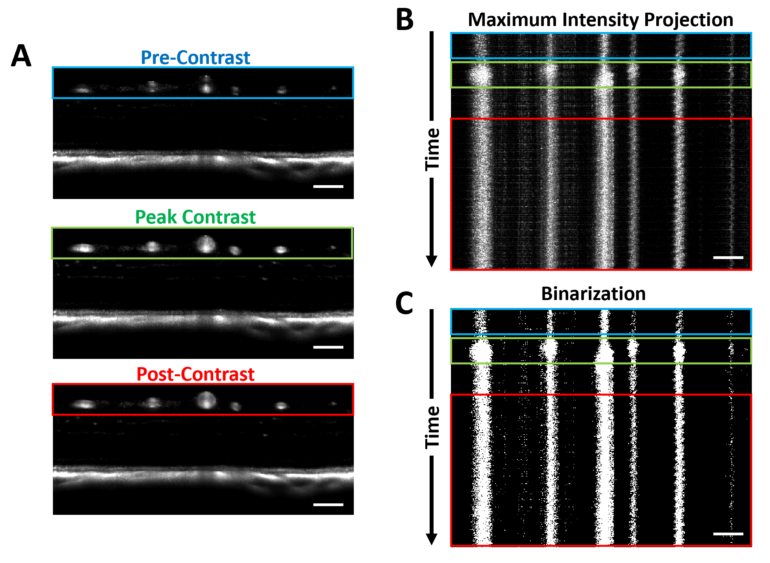

Figure 1. Comparison of angiogram signals at different phases of contrast agent passage. A) A fixed cross-sectional angiogram region before contrast administration (blue), at peak contrast (green), and after contrast passage (red). B) A maximum intensity projection of surface vasculature over time showing color coded regions for contrast agent injection phase. C) The binarized angiogram over time resulting from a global threshold applied to the projection from B.

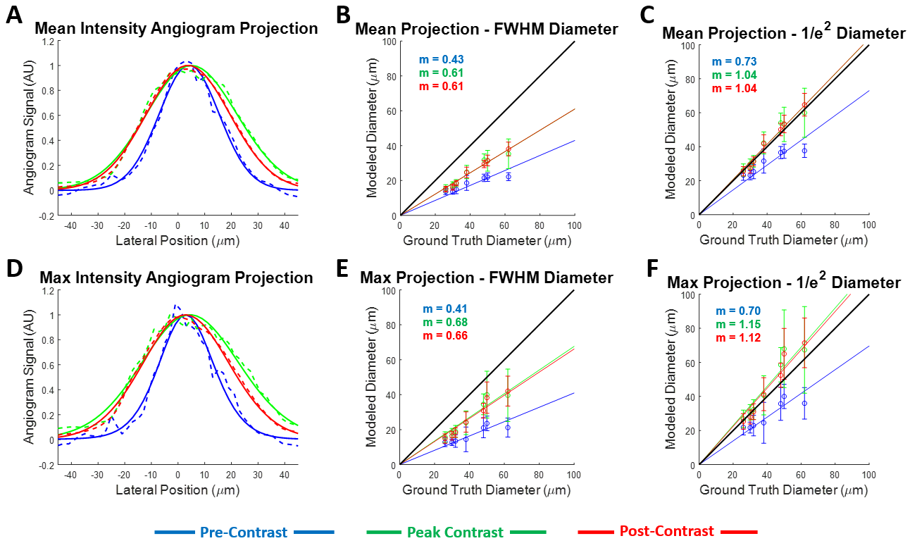

Figure 2. Comparison of mean (A-C) and maximum intensity (D-F) projections of vessels for estimating vessel diameter using a Gaussian model. A,D) Normalized vessel profiles at different contrast phases. Full width at half maximum (FWHM) (B,E) and 1/e² (C,F) estimations of vessel diameter at different contrast phases for 7 vessels across 2 mice. Data points are the mean diameters across the range of time points in each phase, and error bars are the standard deviations of these diameters. Colored lines show the best linear fits to the data with a fixed x,y intercept through 0,0. The unity line shown in black.

References
1. Ahmed Javed, Aishwarya Khanna, Eleanor Palmer, Craig Wilde, Anwar Zaman, Gavin Orr, Dharmalingam Kumudhan, Arun Lakshmanan, and Georgios D Panos, "Optical coherence tomography angiography: a review of the current literature," J. Int. Med. Res. 51(7), 03000605231187933 (2023).
2. P. Cimalla, J. Walther, M. Mittasch, and E. Koch, "Shear flow-induced optical inhomogeneity of blood assessed in vivo and in vitro by spectral domain optical coherence tomography in the 1.3 μm wavelength range," J. Biomed. Opt. 16(11), 116020 (2011).
3. C. W. Merkle and V. J. Srinivasan, "Laminar microvascular transit time distribution in the mouse somatosensory cortex revealed by Dynamic Contrast Optical Coherence Tomography," Neuroimage 125, 350–362 (2016).
4. M. T. Bernucci, C. W. Merkle, and V. J. Srinivasan, "Investigation of artifacts in retinal and choroidal OCT angiography with a contrast agent," Biomed. Opt. Express 9(3), (2018).
5. J. Zhu, M. T. Bernucci, C. W. Merkle, and V. J. Srinivasan, "Visibility of microvessels in Optical Coherence Tomography angiography depends on angular orientation," J. Biophotonics 13(10), e202000090 (2020).
6. S. Fialová, M. Augustin, M. Glösmann, T. Himmel, S. Rauscher, M. Gröger, M. Pircher, C. K. Hitzenberger, and B. Baumann, "Polarization properties of single layers in the posterior eyes of mice and rats investigated using high resolution polarization sensitive optical coherence tomography," Biomed. Opt. Express 7(4), 1479–1495 (2016).

